System Security Lab EndSem Evaluation

Praneesh R V

CB.SC.U4CYS23036

Qn1,

a)

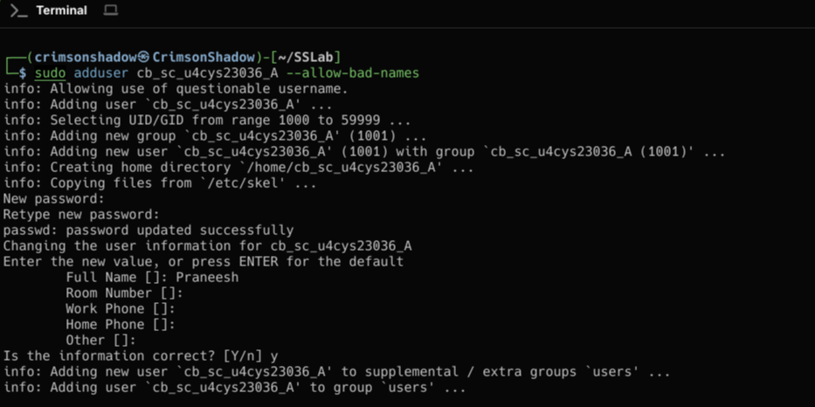

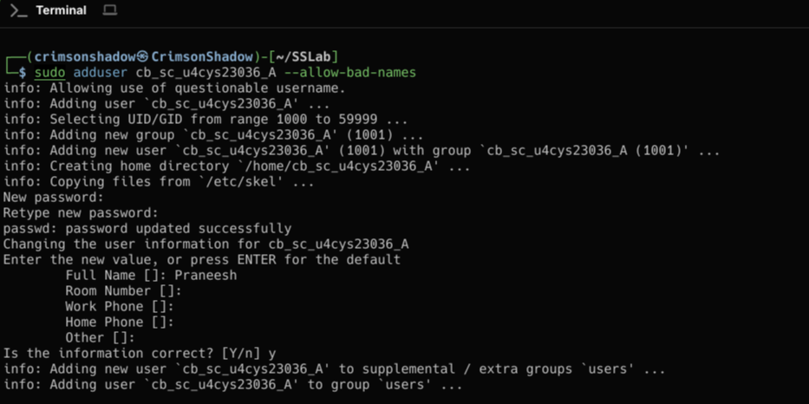  
b)

Entries in linux user management files

/etc/passwd - contains basic info about users

Separated by colon



Username, password placeholder, userID, GroupID, user info, home directory, default shell

c)

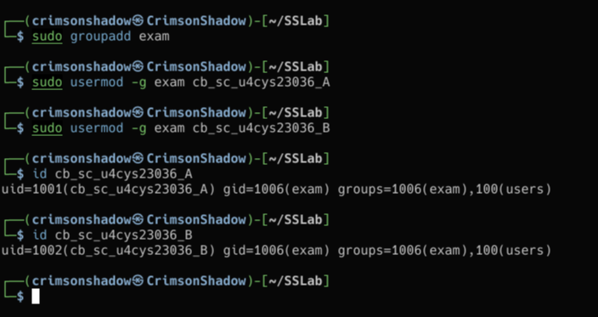

* Default shell

Qn2,

Making /bin/ls a SetUID Program

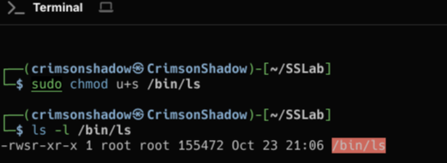

Yes, it can be Undone

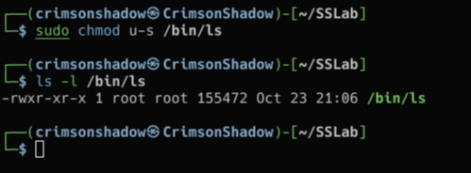

Qn3,

a)

Symlink

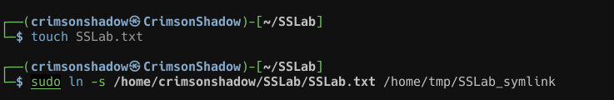

Hardlink



b)

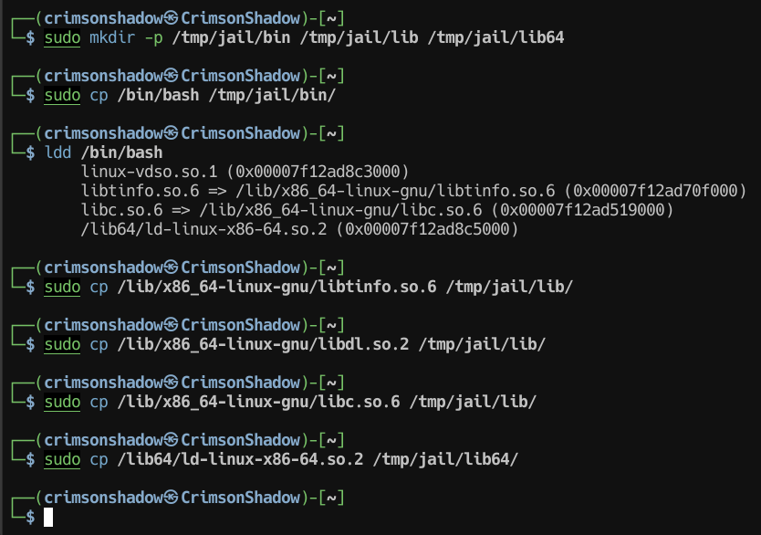

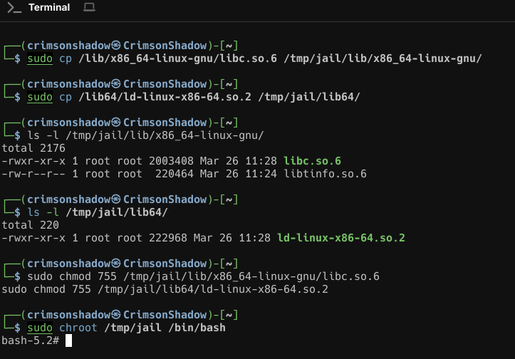

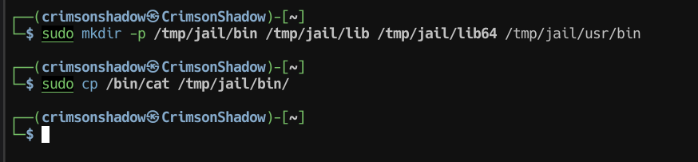

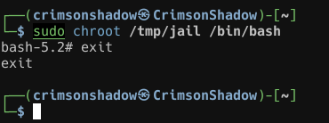

c)

Yes, symbolic links still point to the original file outside /tmp allowing escape.

d)

No, Hardlinks keep the file inside /tmp, preventing escape

e)

Most chroot prevent SetUID execution and prevents escape

Qn4,

a)

Math lib source file

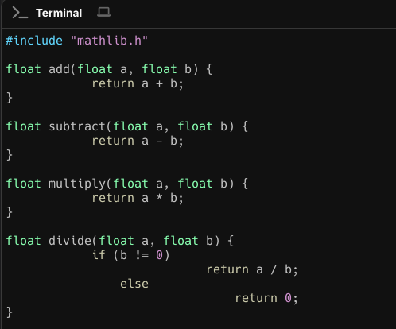

Mathlib headerfile

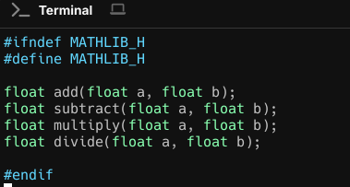

b)

Static and dynamic libraries

i)static

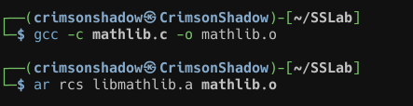

ii)dynamic

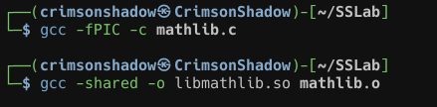

c)Program

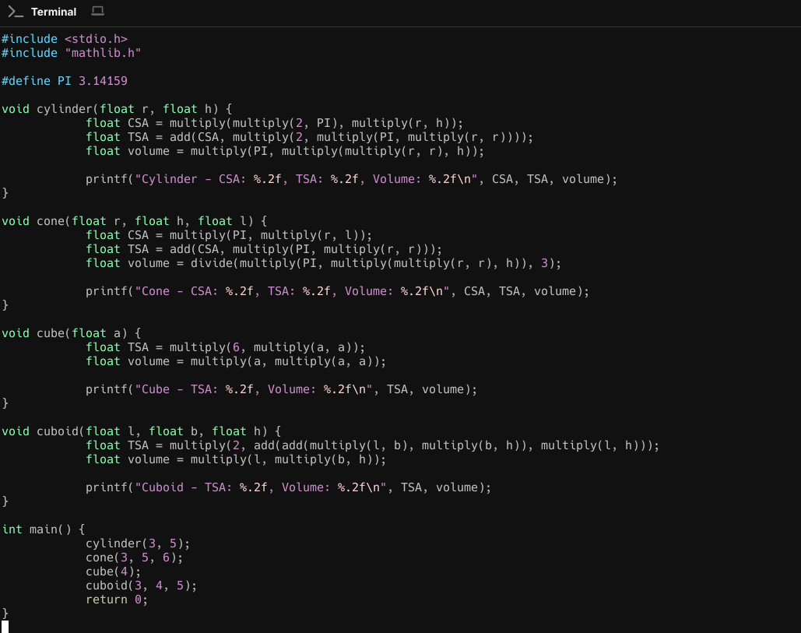

d) Makefile

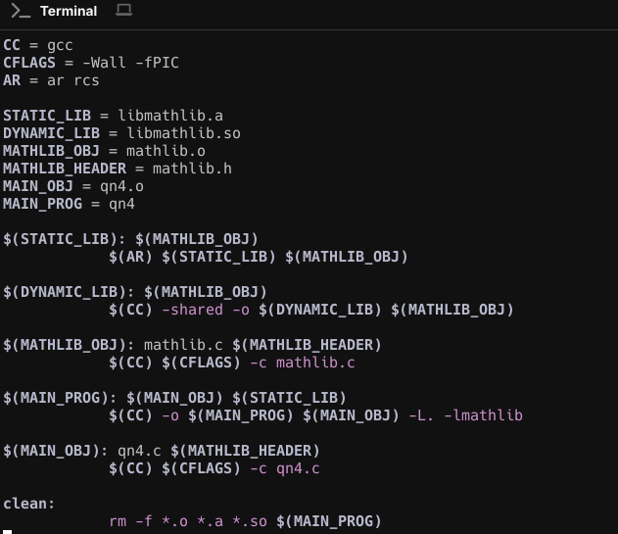

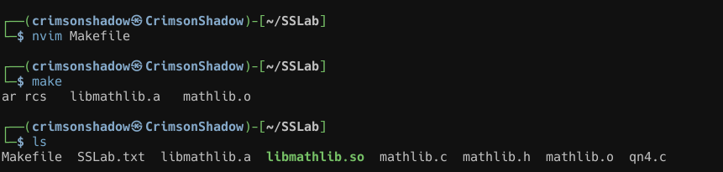

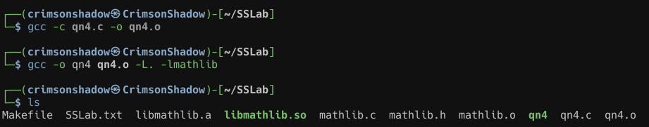

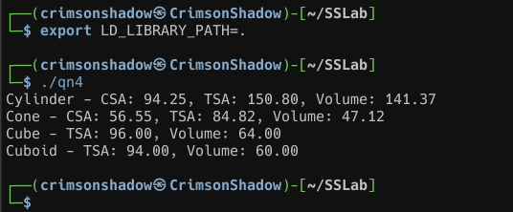

Qn 5,

a)

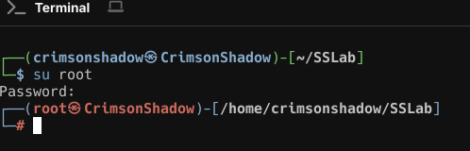

b)

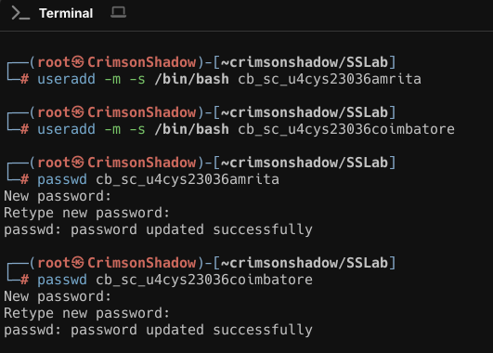

c)

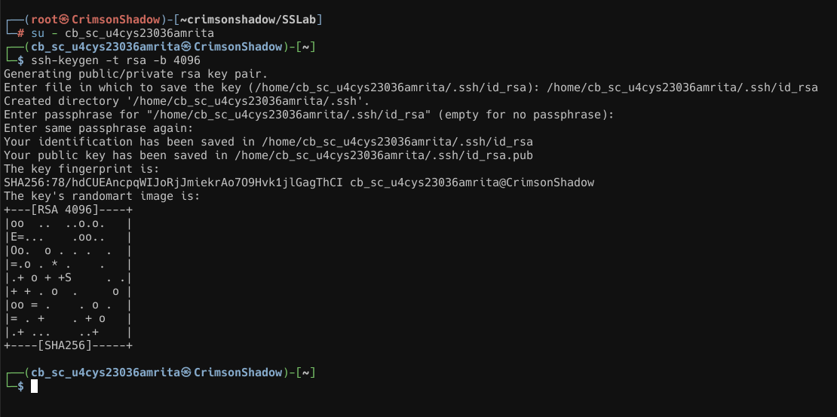

d)

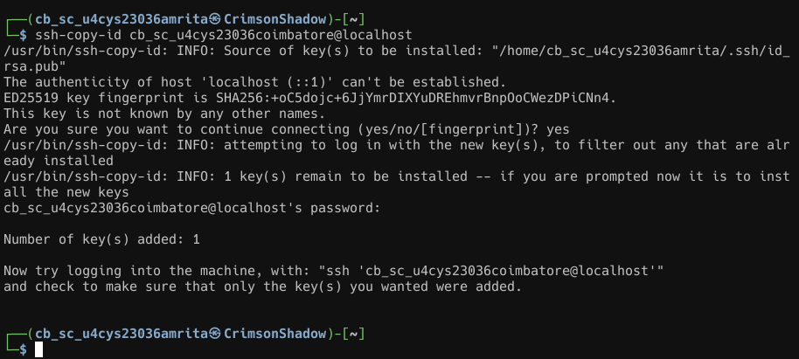

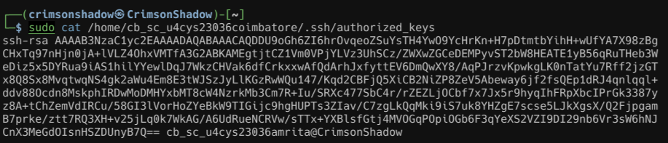

e)

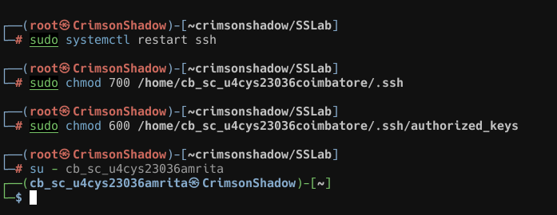

f)Connected without password

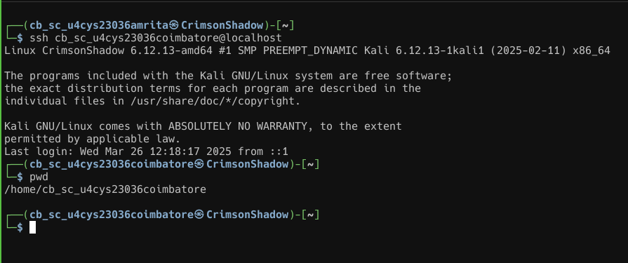

g)

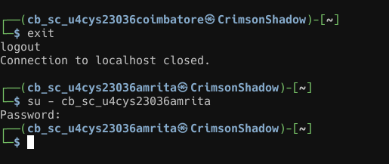

h)

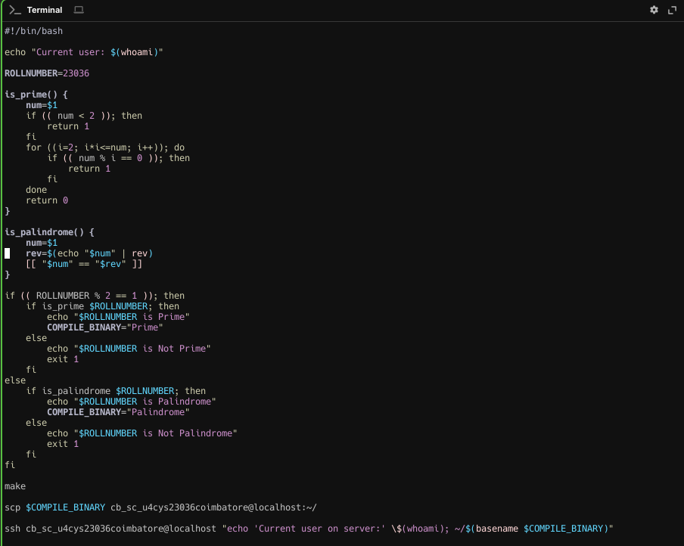

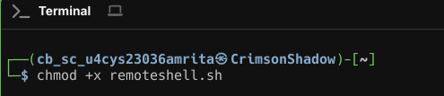

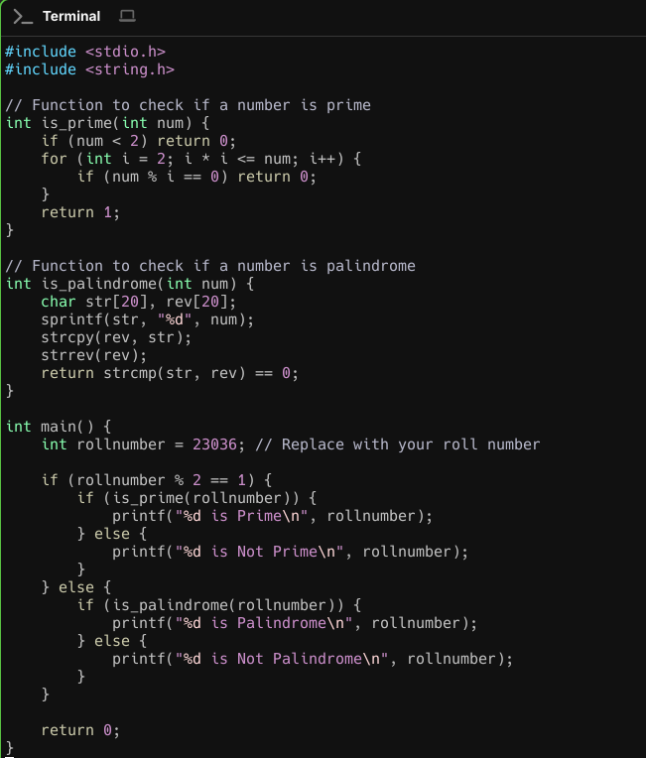

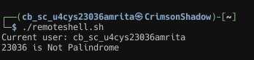

Qn6,

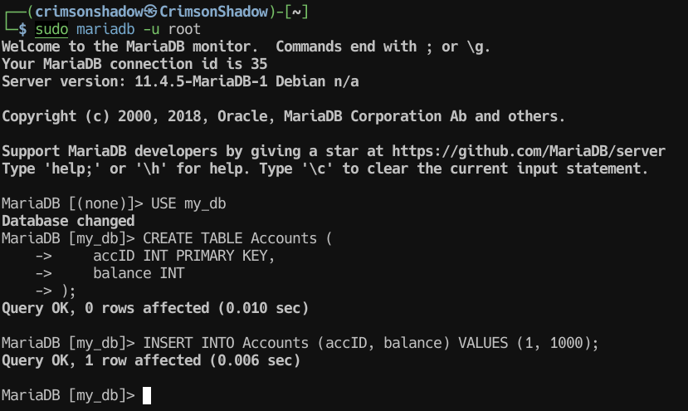

Transaction 1

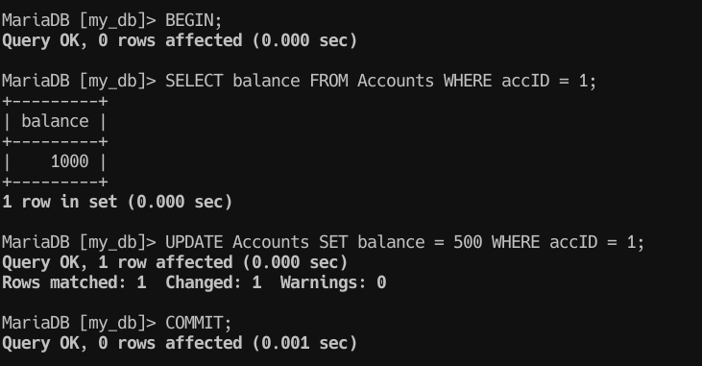

Transaction 2

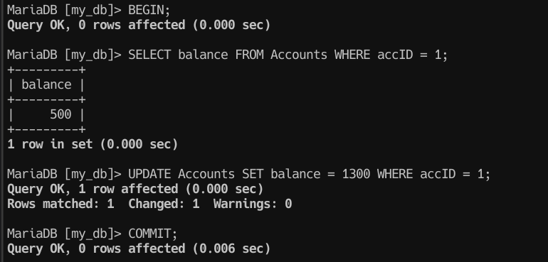

Balance

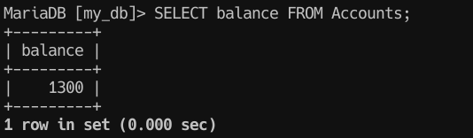

In transaction 1, you should withdraw 500 and in Transaction 2, you should deposit 300,

So, the correct balance should be 800, but due to blind overwriting,

It becomes:

If Transaction 1 commits last → Balance = ₹500 ₹1000 - ₹500

If Transaction 2 commits last → Balance = ₹1300 ₹1000 + ₹300

To fix this,

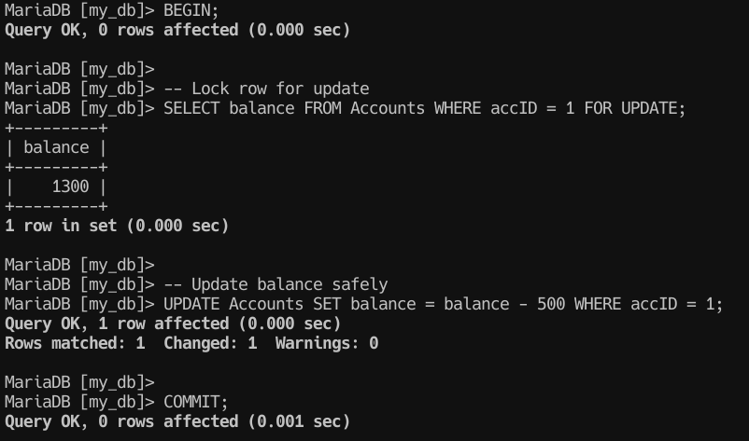

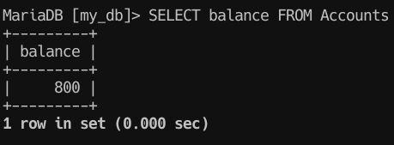  
  
Now balance is correct